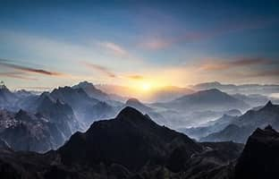
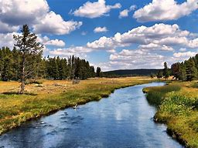
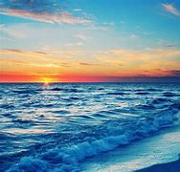
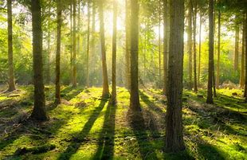

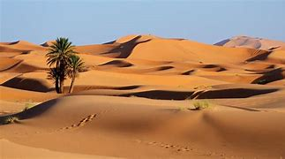
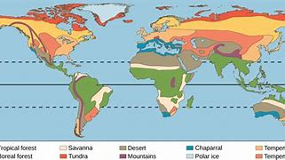

- Używając styli stwórz spis treści (użyj trzech rodzajów nagłówków, żeby zróżnicować paragrafy).
- Rozmieść zdjęcia do odpowiednich sekcji, dodaj automatyczne podpisy, zadbaj o dobre/przejrzyste formatowanie zdjęć względem tekstu.
- Na końcu dokumentu stwórz automatyczny spis rysunków I nazwij go “Spis rysunków”.
- W podsumowaniu dodaj wykres (rysunek z mapą) wraz z odpowiednim podpisem (figure), stwórz spis wykresów.

Title: The Wonders of the Natural World
Introduction The natural world is full of wonders that amaze and inspire. From towering mountains to deep oceans, the diversity of landscapes and ecosystems is staggering.
Section 1: Mountains
• 1.1 Majesty of Mountains The majesty of mountains has captivated humans for centuries. They are not just natural wonders but also vital to the earth’s ecology.
• 1.2 Ecological Importance Mountains play a critical role in maintaining the earth's climate and harboring unique biodiversity.
Section 2: Rivers
• 2.1 Significance of Rivers Rivers are the lifeblood of the earth, providing water for drinking, agriculture, and transportation.
• 2.2 Ecosystems and Landscapes They shape landscapes and support diverse ecosystems with their unique characteristics.
Section 3: Oceans
• 3.1 The Vast Oceans Covering over 70% of the Earth's surface, oceans are vast and mysterious.
• 3.2 Marine Life Oceans are home to a myriad of creatures and play a crucial role in regulating climate.
Section 4: Forests
• 4.1 The Earth’s Lungs Forests are the lungs of the earth, absorbing carbon dioxide and producing oxygen.
• 4.2 Biodiversity They are also home to an incredible variety of flora and fauna, contributing to Earth's biodiversity.
Section 5: Deserts
• 5.1 Understanding Deserts Deserts, often seen as barren wastelands, are in fact ecosystems teeming with life.
• 5.2 Life in Aridity They show the resilience and adaptability of nature in harsh conditions.
Conclusion The natural world, in all its variety, is a constant source of wonder and inspiration. It is a reminder of the beauty and complexity of our planet.

